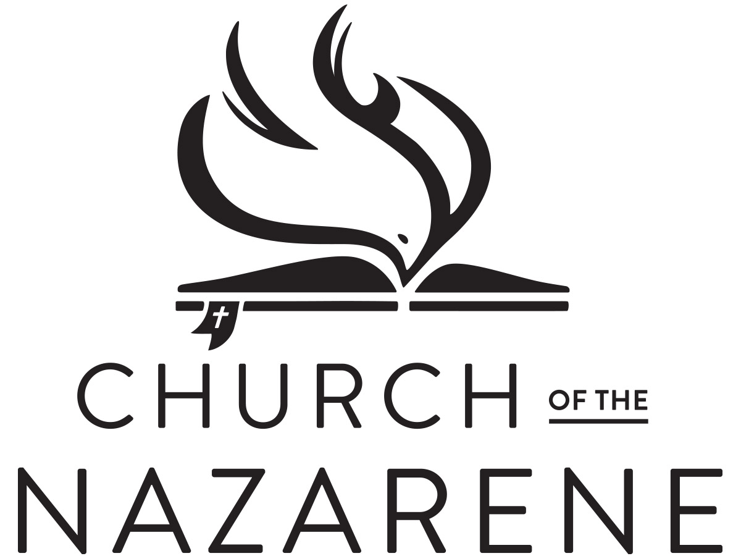

**LOCAL MINISTER’S LICENSE**

This is to certify that

Is licensed as a Local Minister

in the Church of the Nazarene for one year, provided that

his/her spirit and practice are such as become the gospel of Christ,

and his/her teachings correspond with the established doctrines

of the Holy Scriptures as held by said church.

By Order of the Church Board of the

Your Town Church of the Nazarene.

Done at Your Town, Ohio this 14th day of March, 2030

John Brown

Church Board Secretary

Pastor

**LOCAL MINISTER’S LICENSE**

This is to certify that

Is licensed as a Local Minister

in the Church of the Nazarene for one year, provided that

his/her spirit and practice are such as become the gospel of Christ,

and his/her teachings correspond with the established doctrines

of the Holy Scriptures as held by said church.

By Order of the Church Board of the

Your Town Church of the Nazarene.

Done at Your Town, Ohio this 14th day of March, 2030

John Brown

Church Board Secretary

Pastor